# Concrete Quality Attribute Scenarios Evaluation

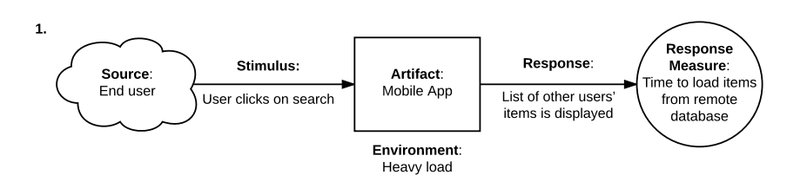

This scenario presents a single **risk**. The system may not comply with the ASR requirement of less than one second to complete a task. During test, the time of response varied from 2 to 5 seconds.

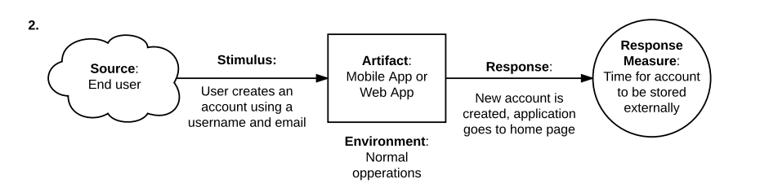

The second scenario presents another **risk** related to security. Password isn’t required for user to login, hence, increases vulnerability of system.

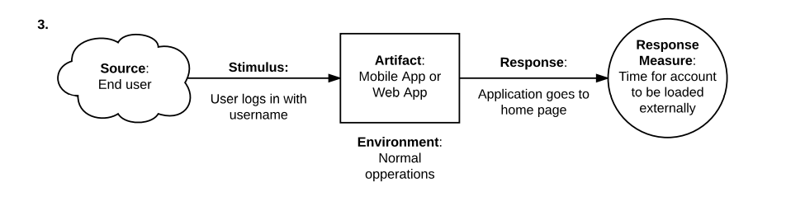

This third scenario is demonstrates a **trade off** between performance and security. If the user logs into system just using username, time for account to be loaded is relatively fast, but includes compromised security because only username is used to login. Using email id as well for login increases security but decreases performance, as time taken for account to be loaded increases.

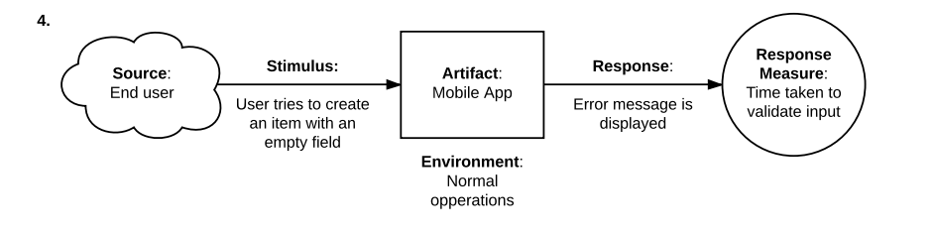

This scenario is an example of **Non-risk**, as user is itself trying to create a nameless item, and the system response was under expected behavior.

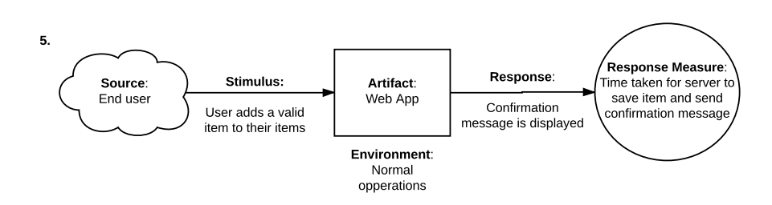

Another **non-risk**, as the operation performed by the user has ended successfully and the system response was under the expected time.

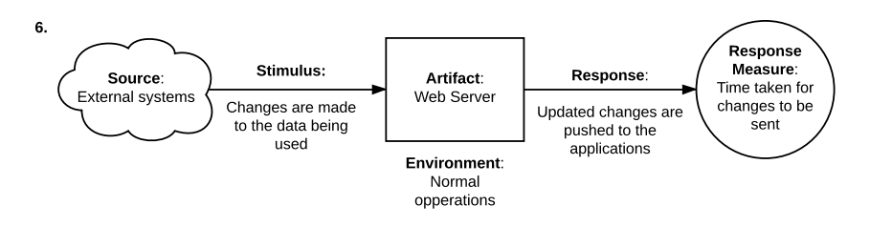

This scenario presents a **sensivity point**, the sync of data – the user may be using stale data. Invert the push strategy to pull on the data sync can minimize the problem.

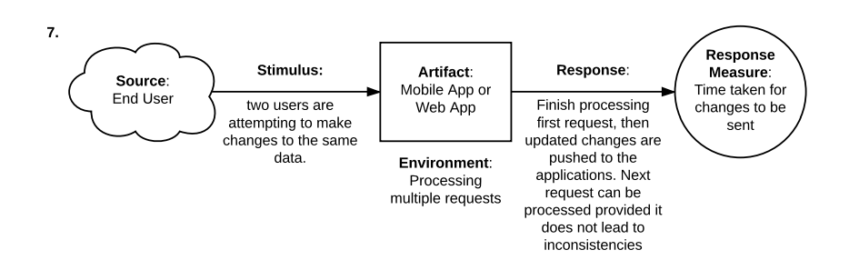

It’s a **non risk**, the system treats multiple attempt to change same data by locking the resources and executing a single operation at a given time., this leads to fault tolerance and consistency of data across the system.

# Updated Utility Tree

